Assignment 1b
Yalin Sun

Part 1
(1) Successfully launch an EC2 instance
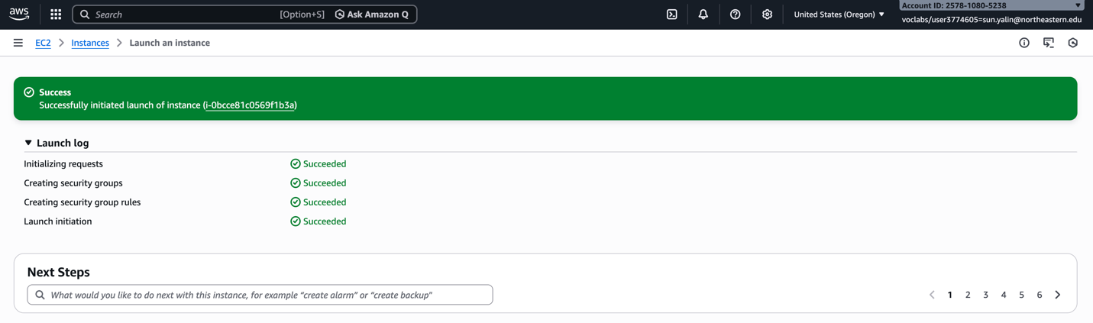

(2) Connected to the EC2 instance
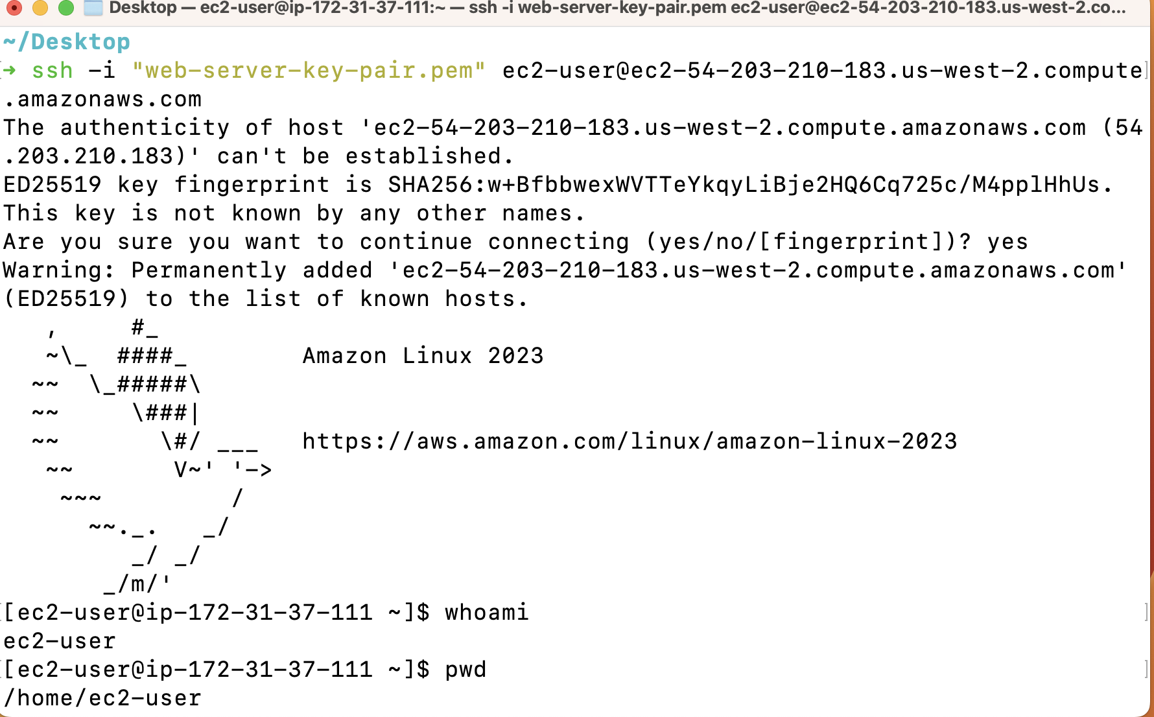

(3) Cross compile Go-Gin code
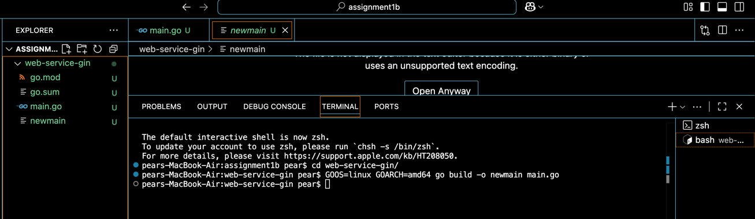

(4) Upload the compiled file
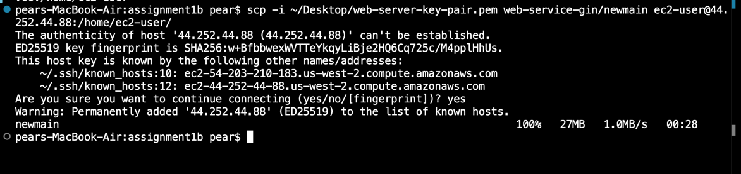

(5) Run the Go server
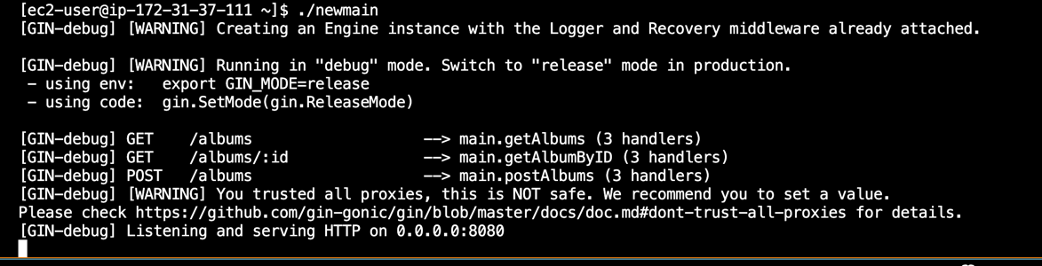

(6) Successfully sent the HTTP GET request and get the result
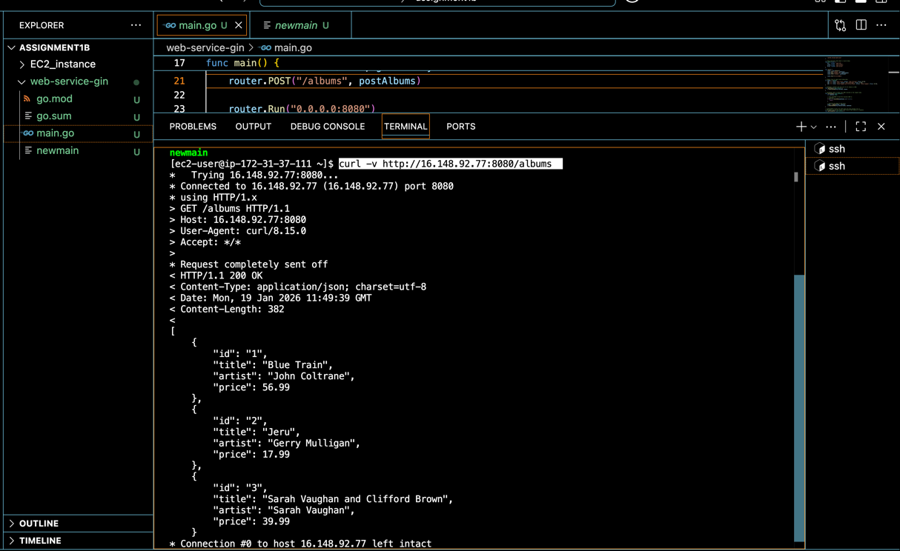
(7) sent HTTP POST request successfully
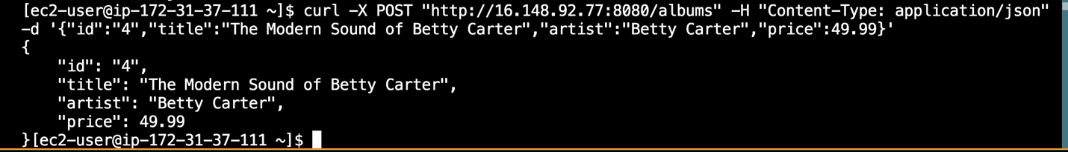

(8) sent HTTP GET-id request successfully
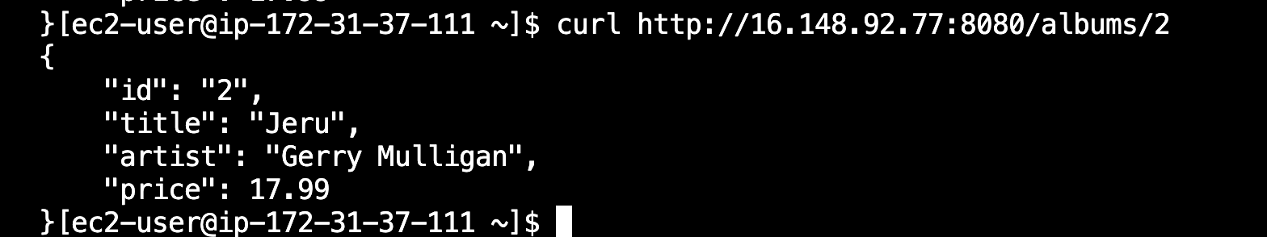

Part III
(1) Screenshot of the running results:
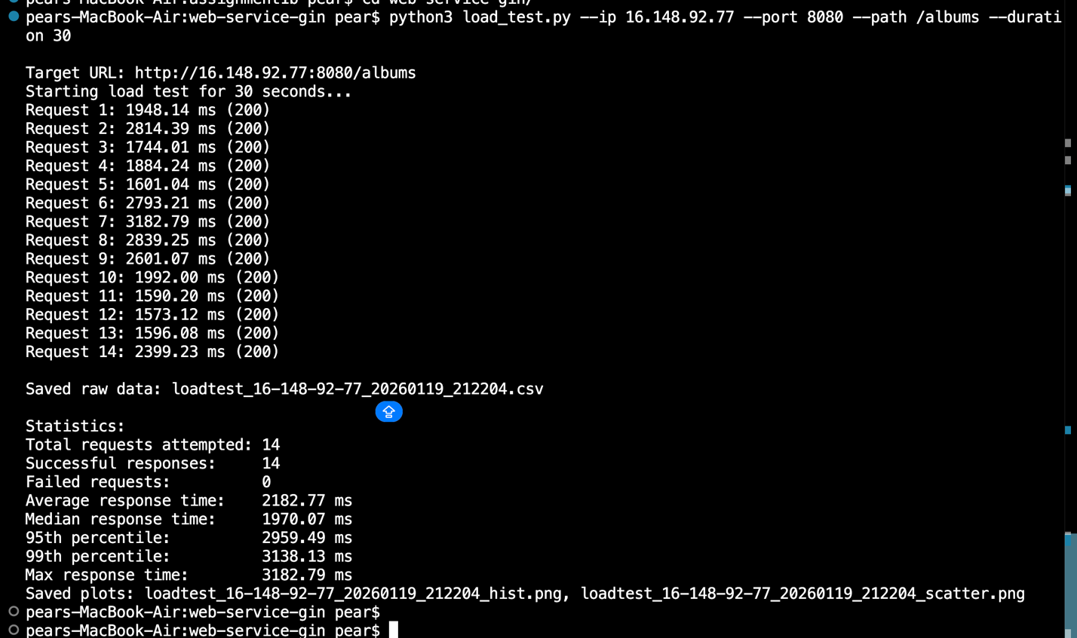
(2) Answers to the questions:
1. Distribution Shape
Yes, the histogram shows a clear long-tail distribution. Most requests fall between 1500–2000 ms, while a few requests take much longer, up to 3000+ ms. These slower responses form the “tail” of the distribution. Roughly the slowest 5–10% of requests can be considered part of this long tail.
2. Consistency
The response times are not completely consistent over the 30-second window. The scatter plot shows several noticeable spikes where latency increases significantly. This indicates that some requests experience delays even though most complete in a similar time range.
3. Percentiles
The median (50th percentile) response time is about 1970 ms, while the 95th percentile is around 2960 ms. This large gap of nearly 1 second shows high variability. It means that while most users experience moderate latency, a small group experiences much slower responses.
4. Infrastructure Impact
This service runs on a single, basic EC2 instance. Limited CPU, memory, and lack of load balancing can easily cause performance fluctuations. Since all requests are handled by one machine, any temporary resource contention can significantly increase response time.
5. Scaling Implications
If there were 100 concurrent users, performance would likely degrade quickly. Requests would queue, response times would increase, and more extreme tail latency would appear. Without scaling, this system would struggle under heavier load.
6. Network vs. Processing
The longer response times are likely caused by both network latency and server-side processing delays. To investigate further, I could run the test from inside the EC2 instance using localhost and compare the results with external tests.

